On March 23, 2020, professional nursing organizations, including the National League for Nursing, the Organization for Associate Degree Nursing and the American Association of Colleges of Nursing, sent out an urgent national call to action for college nursing programs to donate any personal protective equipment (PPE) to their local hospitals and health systems.

In response, the Maryland Higher Education Commission (MHEC) Nurse Support Program II (NSPII) sent out an urgent request to the Deans and Directors of all 28 nursing programs in Maryland. In the last four days, an overwhelming response came from nursing programs at:
- Johns Hopkins University
- University of Maryland at Baltimore
- University of Maryland at Shady Grove
- Towson University
- Stevenson University
- Salisbury University
- Notre Dame of Maryland University
- Frostburg State University
- Hood College
- Hagerstown Community College
- Anne Arundel Community College
- Carroll Community College
- Wor-Wic Community College
- Howard Community College
- Frederick Community College
- College of Southern Maryland
- Harford Community College, and
- Prince George's Community College

The Health Services Cost Review Commission and the Maryland Higher Education Commission worked with the nursing programs to coordinate donating the following equipment and PPE from their student Clinical Simulation Centers to their partner hospitals or local health systems.
- Ventilators.
- Eye protection and goggles
- Face shields
- Surgical masks
- N95 masks
- Non-sterile gloves
- Sterile gloves
- Disposable gowns
- Biohazard bags

All of the institutions mentioned had donated or were in the process of donating the much-needed equipment to hospitals at Johns Hopkins Hospital and Health Systems, University of Maryland (UM) Medical Center, UM Charles Regional Medical Center, UM Upper Chesapeake Health, UM St. Joseph’s Medical Center, Frederick Memorial Hospital, Calvert County Hospital, MedStar St. Mary’s Hospital, Western Maryland Health System, Peninsula Regional Hospital, Atlantic General Hospital, Sinai Hospital, Greater Baltimore Medical System, Medstar Southern Maryland and UM Baltimore Washington Medical Center. Some PPE was also donated across the state to county public health departments and first responders in western Maryland, southern and northern Maryland areas by several community colleges for local distribution.

The photo below was submitted by Harford Community College’s Nursing Director, Laura Preston, taken as they loaded 427 boxes of gloves (100/box), 77 boxes of gloves (200/box) 760 face mask and 771 isolation gowns to UM Upper Chesapeake Health.

The photos below were submitted by PGCC's Nursing Director, Vivian Kuawogai , taken as they loaded up their PPE on Tuesday, March 24th. The remaining schools are reporting back and in the process of donating clinical PPE.

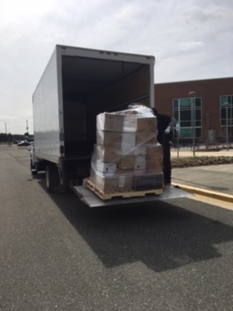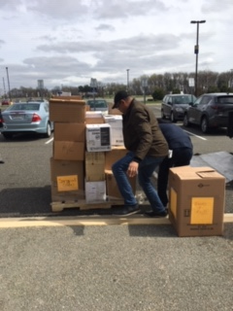

Nurses and frontline health care providers are using these PPE to deliver safe care.

MHEC wishes to thank everyone for supporting our Maryland hospitals and health systems!

