Student Learner Instructions to Create an Account and Log In

Create a new account (first time users)
- Go to URL: https://jhu.mediashareiq.com/

- Click Create Account
- Enter the following information to sign up for a new account
- First name, Last name
- Email
- Password, Confirm Password
- Role = Learner
Note: All newly created passwords must include at least 6 characters with at least one lower case letter, one upper case letter, one number and one special character.
- You will receive an email to activate your account, directing you to https://jhu.mediashareiq.com/

Log into your account

- https://jhu.mediashareiq.com/
Click Login
- Email
- Password

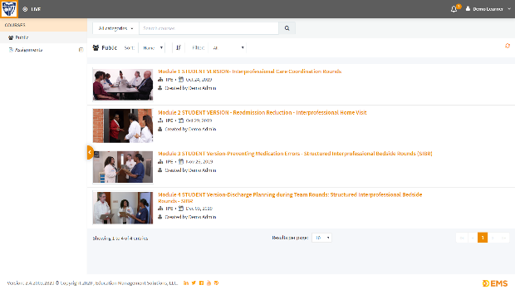
- Four IPE Simulation modules for virtual clinical experience will be listed. Your faculty member will let you know which module you will be using in your clinical course. Click the assigned module to begin.

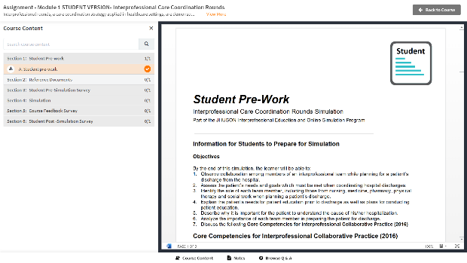
- Each module has several sections: Student Pre-work, Reference Documents, Pre-Simulation Survey, Simulation Video, Course Feedback and Post-Simulation Survey. Complete all the sections. NOTE: Your faculty member may assign additional work to complete a Virtual Clinical Simulation(s)

